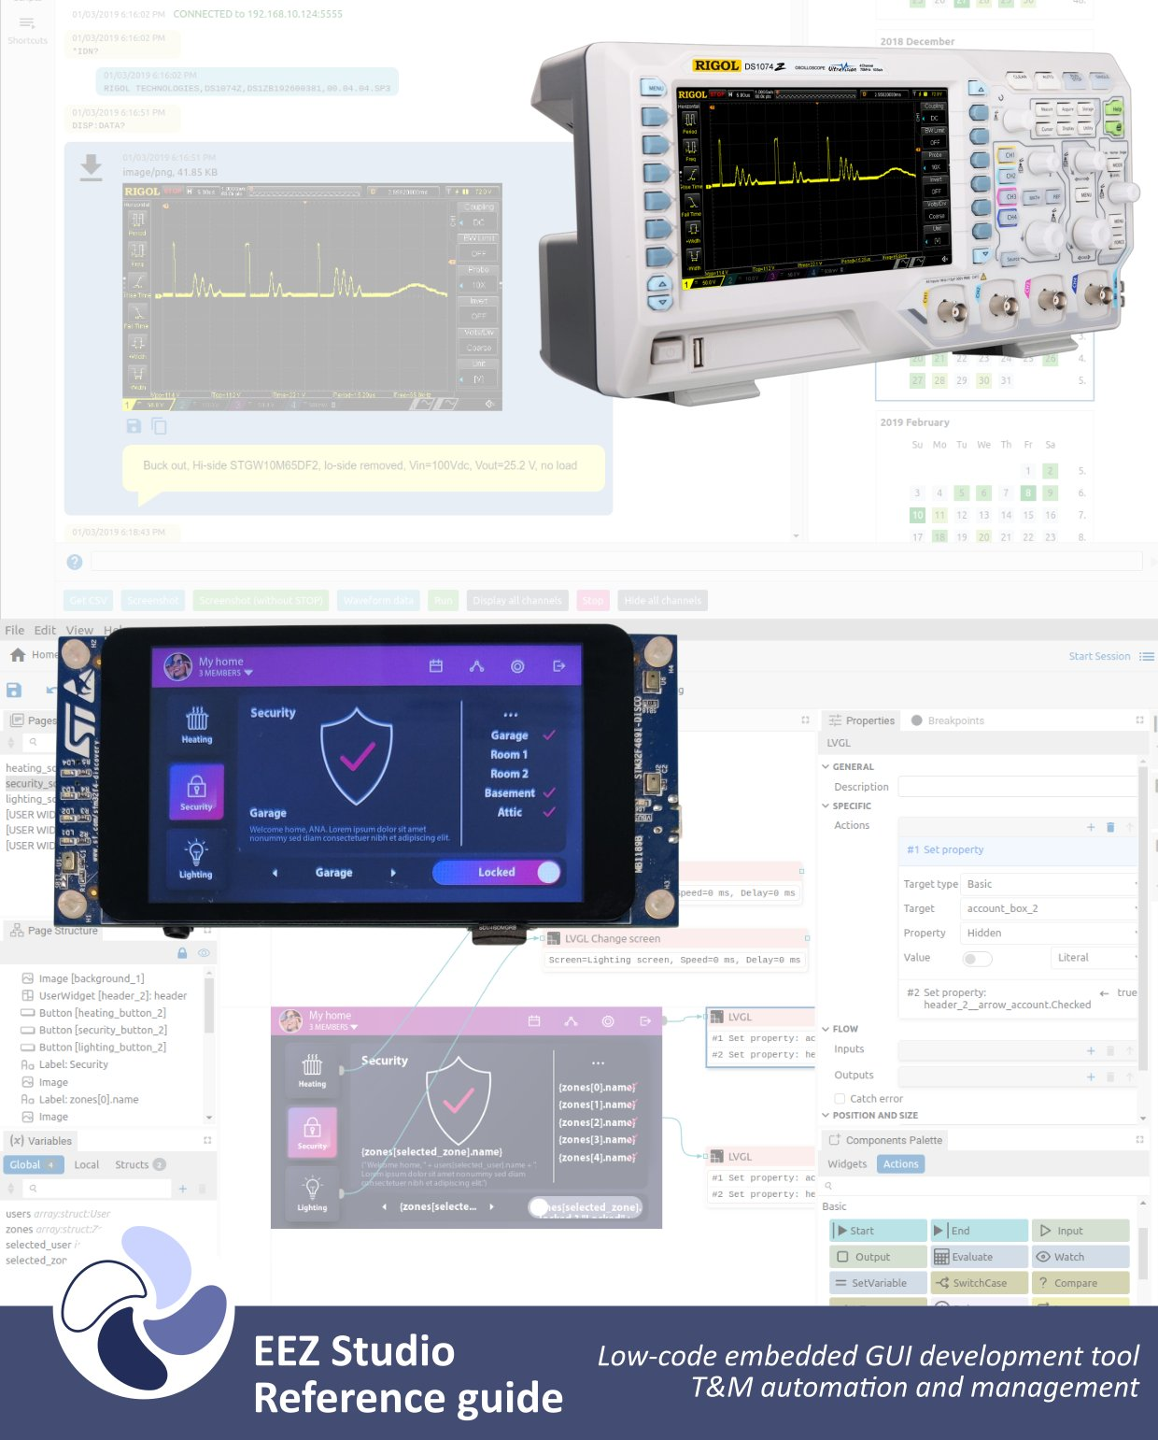
Ver. 0.26.0 – 02/2026
www.envox.eu
github.com/eez-open

